**Title: Evaluate the effectiveness of SHIELD Illinois COVID testing program in underrepresented zip codes**

**Background**

SARS-CoV-2 is the virus strain that causes Coronavirus Disease 2019 (COVID-19). It was discovered for the first time in Wuhan, China, around the end of December 2019, and it quickly spread to almost every nation. As of early April 2020, COVID-19 had infected over 1.5 million people and killed over 88 thousand people globally [1]. The COVID-19 outbreak created many difficulties for US hospitals trying to maintain high standards of treatment [2]. Research findings indicate that patients with co-morbid conditions such as asthma, COPD, tuberculosis, pneumonia, acute respiratory distress syndrome (ARDS), diabetes mellitus, hypertension, renal disease, hepatic disease, and cardiac disease, as well as male gender and age over 60, are at an increased risk of dying or experiencing unfavorable outcomes. Patients with coronavirus infections have highly varied outcomes. Research also revealed that between 3% and 100% of verified cases, a larger percentage of coronavirus-infected individuals required ICU admission. Additionally, studies revealed that between 6% and 86% of hospitalized patients in critical care had a coronavirus infection, which was a very high rate of mortality [3].

The COVID pandemic has made health inequities worse, with underrepresented communities seeing greater rates of morbidity and mortality than the overall population [4]. According to earlier research, socioeconomic risk factors like food insecurity, homelessness, and poverty can also have a negative impact on people's health during a pandemic [5], [6]. Research by Zeng et al. (2022) revealed that low vaccination rates in some Chicago zip codes were linked to greater COVID mortality rates, aggravating already-existing racial and ethnic differences in death rates [7].

Soon after the virus genome was made public, tests to identify COVID-19 were created [8]. For clinical and public health applications, a wide range of COVID-19 tests are available. The point of care (POC), a central laboratory, or a community setting like a home, workplace, or school can all be used for testing [9]. The University of Illinois System's SHIELD Illinois (also referred to as "SHIELD") effort aims to provide the cutting-edge saliva-based COVID-19 test to K–12 schools, colleges, universities, businesses, and the public throughout the state of Illinois. Testing for SHIELD started in the fall of 2020. During its time, SHIELD expanded quickly. In the fall of 2020, SHIELD processed less than 5,000 tests; by May 2021, it processed 85,500 tests; and by January 2022, it processed slightly under 900,000 tests. In May 2022, SHIELD cleared the 6-million-test level, and in February 2023, it surpassed the 7-million-test threshold. SHIELD Illinois is a statewide initiative offering free COVID testing to all residents. While the program has successfully increased testing rates across Illinois, its effectiveness in improving COVID outcomes in underserved communities remains unclear. The program has amassed extensive data on testing, encompassing the number and types of tests conducted, test results, and demographic information of those tested. This presents a unique opportunity to gain a comprehensive understanding of the impact of SHIELD Illinois on the health of underrepresented communities in Chicago, especially when combined with data from the Chicago Department of Public Health and Electronic Health Records.

To our best knowledge, this is the first study to evaluate the impact of SHIELD testing program on the ICU outcomes (e.g., admission rate and length of stay). By doing this study, we are able to answer the following question:

What is the impact of number of SHIELD covid testing centers and samples collected on the ICU outcomes (e.g., ICU admission rate and number of ICU admissions) during different COVID waves (i.e., Alpha, Delta, and Omicron)?

**Methods**

**Study Design and Population**

We utilized datasets from the ICU at Loyola University Chicago covering the period from January 2020 to December 2022. To identify patients without COVID-19 symptoms, we applied the COVID-19 ICD-10 codes (see **Table 1**). We then excluded zip codes with fewer than 1,000 residents and removed any duplicate visits to create the final dataset (see **Figure 1**). Additionally, all procedures conducted in this study were approved by the Loyola University Chicago Institutional Review Board.

The primary goal of this study is to determine if the SHIELD testing program negatively impacts ICU outcomes, such as ICU admission rate and the number of ICU admissions, during various COVID-19 waves. These waves include the Alpha wave (March 2021- June 2021), Delta wave (August 2021-November 2021) [10], and Omicron wave (December 2021-March 2022) [11].

**Data Description**

As previously mentioned, we sourced the data from the ICU at Loyola University Chicago. After cleaning the data, we had a total of 5,780 ICU visits (from 5,268 ICU patients) between January 2020 and December 2022, covering 417 zip codes across Illinois (see **Figure 2**). A detailed description of the data can be found in Table 2. Based on a study done by Hu et al., (2018) [12], we categorized all zip codes with ADI score from one to five as “less disadvantaged” and all zip codes with score of six to ten as “more disadvantaged”.

For the Alpha wave, detailed descriptive analysis is provided in Table 3, covering 581 patients from 205 zip codes. The gender distribution was 56.95% male and 43.04% female. Racial demographics included 27.97% Black, 49.91% White, 19.76% Other, and 2.34% Unknown. Ethnicity was recorded as 20.93% Hispanic, 75.87% Non-Hispanic, and 3.18% Unknown. The median age of patients was 59 years, with 63.48% aged 18-64 years and 36.51% aged 65 years or older. Insurance status showed that 96.64% were insured, while 3.35% were uninsured. Among these patients, 10.88% had no COVID-19 diagnosis, and 89.11% had a COVID-19 diagnosis. Regarding the ADI, 64.15% of patients were from less disadvantaged areas, and 35.84% were from more disadvantaged areas. The median ICU length of stay was 2 days, with an interquartile range (IQR) of 1-7 days. The median number of samples collected monthly was 37, with an IQR of 15-66. Table 4 provides a descriptive analysis for the Delta wave, covering 696 patients from 215 zip codes. The gender distribution was 59.5% male and 40.49% female. The racial breakdown included 24.27% Black, 51.73% White, 21.08% Other, and 2.91% Unknown. Ethnicity data showed 22.33% Hispanic, 74.89% Non-Hispanic, and 2.77% Unknown. The median age was 61 years, with 63.24% of patients aged 18-64 years and 36.75% aged 65 years or older. Insurance status revealed that 98.56% of patients were insured, while 4.43% were uninsured. Among these patients, 86.68% had no COVID-19 diagnosis, and 13.31% had a COVID-19 diagnosis. In terms of ADI, 59.5% of patients were from less disadvantaged areas, and 40.49% were from more disadvantaged areas. The median ICU length of stay was 3 days, with an IQR of 1-7 days. The median number of samples collected monthly was 352, with an IQR of 107,519. Table 5 provides a descriptive analysis for Omicron wave, covering 787 patients from 220 zip codes. The gender distribution was 60.41% male and 39.58% female. The racial composition included 24.53% Black, 50.55% White, 22.31% Other, and 2.58% Unknown. Ethnicity data indicated 27.86% Hispanic, 70.16% Non-Hispanic, and 1.97% Unknown. The median age of patients was 62 years, with 53.88% aged 18-64 years and 46.11% aged 65 years or older. Insurance status revealed that 96.42% were insured, while 3.57% were uninsured. Among these patients, 83.23% had no COVID-19 diagnosis, and 16.76% had a COVID-19 diagnosis. Regarding the ADI, 62.76% of patients were from less disadvantaged areas, and 37.23% were from more disadvantaged areas. The median ICU length of stay was 3 days, with an IQR of 1-8 days. The median number of samples collected monthly was 1,166, with an IQR of 299,577.

**Statistical Analysis**

We examined the relationship between the number of SHIELD centers and samples collected with the COVID ICU admission rate and the number of COVID ICU admissions per zip code per month using two methods. First, we calculated the Pearson correlation coefficient between SHIELD results and COVID ICU outcomes across different waves. Second, we applied mixed-effects Poisson regression models using data from March 2021 to June 2021 for the Alpha wave, August 2021 to November 2021 for the Delta wave, and December 2021 to March 2022 for the Omicron wave. The models included fixed effects for the number of SHIELD centers per zip code per month, the ADI category for each zip code, the number of samples collected per zip code per month, and the interaction between the number of SHIELD centers and samples collected with the ADI category. A zip code–level random intercept was used to account for the clustering of the monthly COVID ICU admission rate and the number of ICU admissions.

All analyses were conducted using R statistical software version 2024.04.1 (R Project for Statistical Computing). The data analysis period spanned from March 1, 2024, to June 20, 2024.

**References**

[1] O. M. Araz, A. Ramirez-Nafarrate, M. Jehn, and F. A. Wilson, “The importance of widespread testing for COVID-19 pandemic: systems thinking for drive-through testing sites,” *Health Systems*, vol. 9, no. 2, pp. 119–123, 2020.

[2] J. S. Adelman and T. K. Gandhi, “COVID-19 and patient safety: time to tap into our investment in high reliability,” *J Patient Saf*, vol. 17, no. 4, pp. 331–333, 2021.

[3] S. M. Abate, S. Ahmed Ali, B. Mantfardo, and B. Basu, “Rate of Intensive Care Unit admission and outcomes among patients with coronavirus: A systematic review and Meta-analysis,” *PLoS One*, vol. 15, no. 7, p. e0235653, 2020.

[4] J. F. Figueroa, R. K. Wadhera, D. Lee, R. W. Yeh, and B. D. Sommers, “Community-Level Factors Associated With Racial And Ethnic Disparities In COVID-19 Rates In Massachusetts: Study examines community-level factors associated with racial and ethnic disparities in COVID-19 rates in Massachusetts.,” *Health Aff*, vol. 39, no. 11, pp. 1984–1992, 2020.

[5] S. Bhayani *et al.*, “Dialysis, COVID-19, poverty, and race in greater Chicago: an ecological analysis,” *Kidney Med*, vol. 2, no. 5, pp. 552–558, 2020.

[6] D. Ge *et al.*, “Screening for Social Risk Factors in the ICU During the Pandemic,” *Crit Care Explor*, vol. 4, no. 10, p. e0761, 2022.

[7] S. Zeng, K. M. Pelzer, R. D. Gibbons, M. E. Peek, and W. F. Parker, “Association of zip code vaccination rate with COVID-19 mortality in Chicago, Illinois,” *JAMA Netw Open*, vol. 5, no. 5, pp. e2214753–e2214753, 2022.

[8] V. M. Corman *et al.*, “Detection of 2019 novel coronavirus (2019-nCoV) by real-time RT-PCR,” *Eurosurveillance*, vol. 25, no. 3, p. 2000045, 2020.

[9] M. J. Mina and K. G. Andersen, “COVID-19 testing: One size does not fit all,” *Science (1979)*, vol. 371, no. 6525, pp. 126–127, 2021.

[10] S. Zeng, K. M. Pelzer, R. D. Gibbons, M. E. Peek, and W. F. Parker, “Association of zip code vaccination rate with COVID-19 mortality in Chicago, Illinois,” *JAMA Netw Open*, vol. 5, no. 5, pp. e2214753–e2214753, 2022.

[11] Centers for Disease Control and Prevention, “CDC Museum COVID-19 Timeline,” https://www.cdc.gov/museum/timeline/covid19.html.

[12] J. Hu, A. J. H. Kind, and D. Nerenz, “Area deprivation index predicts readmission risk at an urban teaching hospital,” *American Journal of Medical Quality*, vol. 33, no. 5, pp. 493–501, 2018.

[13] K. E. Lynch *et al.*, “Positive predictive value of COVID-19 ICD-10 diagnosis codes across calendar time and clinical setting,” *Clin Epidemiol*, pp. 1011–1018, 2021.

[14] AAP Division of Health Care Finance, “New COVID-19-related ICD-10-CM codes take effect,” https://publications.aap.org/aapnews/news/12215/New-COVID-19-related-ICD-10-CM-codes-take-effect?autologincheck=redirected.

[15] L. J. McGrath, A. M. Scott, A. Surinach, R. Chambers, M. Benigno, and D. Malhotra, “Use of the postacute sequelae of COVID-19 diagnosis code in routine clinical practice in the US,” *JAMA Netw Open*, vol. 5, no. 10, pp. e2235089–e2235089, 2022.

[16] E. R. Pfaff *et al.*, “Coding long COVID: characterizing a new disease through an ICD-10 lens,” *BMC Med*, vol. 21, no. 1, p. 58, 2023.

[17] A. S. Bhatt *et al.*, “Accuracy of ICD-10 diagnostic codes to identify COVID-19 among hospitalized patients,” *J Gen Intern Med*, vol. 36, no. 8, pp. 2532–2535, 2021.

[18] O. Byambasuren, P. Stehlik, J. Clark, K. Alcorn, and P. Glasziou, “Effect of covid-19 vaccination on long covid: systematic review,” *BMJ medicine*, vol. 2, no. 1, 2023.

[19] D. of H. S. Commonwealth of Pennsylvania, “ICD-10-CM Official Coding Guidelines Related to COVID-19 ,” https://www.pa.gov/content/dam/copapwp-pagov/en/dhs/documents/providers/providers/documents/coronavirus-2020/COVID-19%20ICD-10%20Guidance%20Quick%20.pdf.

**Figures and Tables**

**Table1:** ICD-10 codes related to the COVID-19

|  |  |
| --- | --- |
| **Covid related ICD-10 code** | **Description** |
| Z11.52 [13], [14] | Contact with and (suspected)exposure to COVID-19 |
| M35.81 [14], [15], [16] | Multisystem Inflammatory Syndrome (MIS) |
| J12.82 [13], [14] | Pneumonia due to Coronavirus disease 2019 |
| U07.1 [13], [14], [15], [16], [17], [18], [19] | COVID-19 |
| U09.9 [15], [16] | Post-COVID-19 condition, unspecified |
| B97.29 [18], [19] | Other Coronavirus as the cause of disease classified elsewhere |
| J20.8 [19] | Acute bronchitis confirmed as due to COVID-19 |
| J22 [19] | Lower or acute respiratory infection due to COVID-19 |
| J98.8 [19] | Respiratory infection due to COVID-19 |
| J80 [19] | Acute Respiratory Distress Syndrome (ARDS) due to COVID-19 |

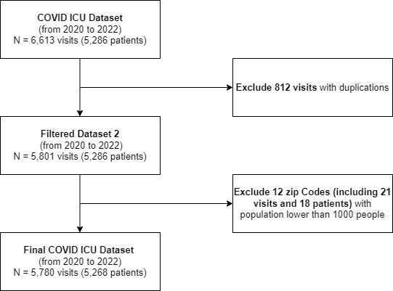

**Figure 1:** Data filtration diagram

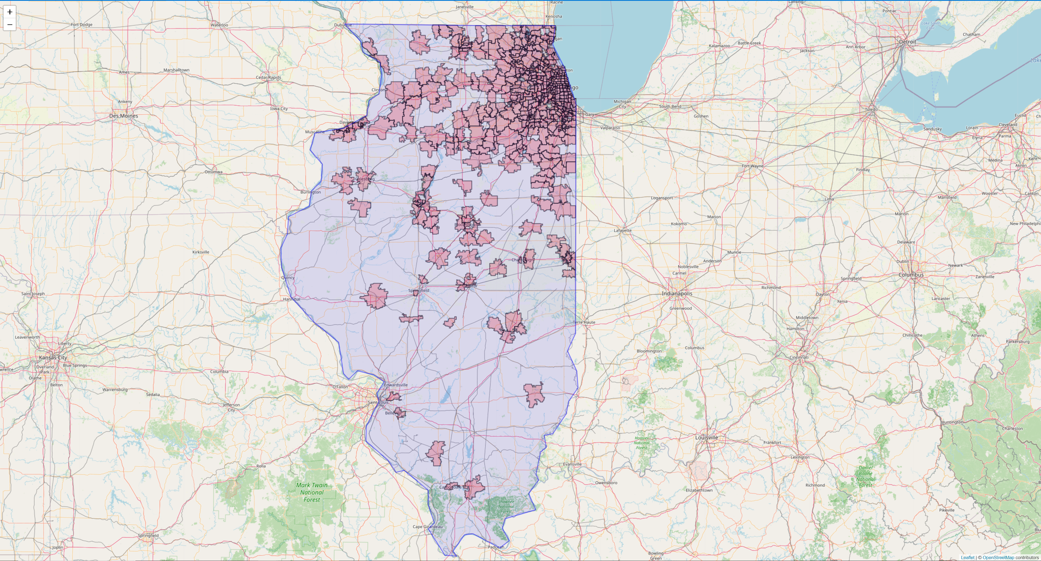

**Figure 2:** Distribution of zip codes in IL with COVID-19 ICU hospitalizations at Loyola hospital

**Table 2:** Details of variables

|  |  |
| --- | --- |
| Variable | Type |
| Zip Code | Categorical |
| Date | Continuous |
| Total COVID ICU admission per zip code per month | Continuous |
| Zip Code population | Continuous |
| COVID ICU admission rate | Continuous |
| Average age | Continuous |
| Average COVID ICU length of stay | Continuous |
| Gender | Categorical (Male/Female) |
| Race | Categorical (White/Black/Other) |
| Ethnicity | Categorical (Hispanic/Non-Hispanic) |
| Insurance status | Categorical (Insured/Uninsured) |
| Total number of SHIELD centers per zip code per month | Continuous |
| Total number of samples collected per zip code per month | Continuous |
| Area Deprivation Index (ADI) score | Categorical (Less disadvantaged/More disadvantaged) |

**Table 3:** Descriptive analysis for Alpha wave

|  |  |  |  |
| --- | --- | --- | --- |
| **Characteristic** |  | **Patients (N=581)** | **Zip Codes (N=205)** |
| Gender | Male, n (%) | 340 (56.95) |  |
|  | Female, n (%) | 257 (43.04) | - |
|  |  |  |  |
| Race | Black, n (%) | 167 (27.97) | - |
|  | White, n (%) | 298 (49.91) |  |
|  | Other, n (%) | 118 (19.76) | - |
|  | Unknown, n (%) | 14 (2.34) | - |
|  |  |  |  |
| Ethnicity | Hispanic, n (%) | 125 (20.93) | - |
|  | Non-Hispanic, n (%) | 453 (75.87) | - |
|  | Unknown, n (%) | 19 (3.18) |  |
|  |  |  |  |
| Age, median (IQR) | 18-64 years, n (%) $$≥65 years, n \left(\%\right)$$ | 379 (63.48) | - |
|  |  | 218 (36.51) | - |
|  |  |  |  |
| Insurance Status | Insured, n (%) | 577 (96.64) | - |
|  | Uninsured, n (%) | 20 (3.35) | - |
|  |  |  |  |
| COVID Death | No, n (%) | 65 (10.88) | - |
|  | Yes, n (%) | 532 (89.11) |  |
|  |  |  |  |
| ADI score | Less Disadvantaged, n (%) | - | 383 (64.15) |
|  | More Disadvantaged, n (%) | - | 214 (35.84) |
|  |  |  |  |
| ICU Length of Stay (days), median (IQR) |  | 2 (1-7) | - |
|  |  |  |  |
| Sample Collected (monthly), median (IQR) |  | - | 37 (15-66) |

**Table 4:** Descriptive analysis for Delta wave

|  |  |  |  |
| --- | --- | --- | --- |
| **Characteristic** |  | **Patients (N=696)** | **Zip Codes (N=215)** |
| Gender | Male, n (%) | 429 (59.5) |  |
|  | Female, n (%) | 292 (40.49) | - |
|  |  |  |  |
| Race | Black, n (%) | 175 (24.27) | - |
|  | White, n (%) | 373 (51.73) |  |
|  | Other, n (%) | 152 (21.08) | - |
|  | Unknown, n (%) | 21 (2.91) | - |
|  |  |  |  |
| Ethnicity | Hispanic, n (%) | 161 (22.33) | - |
|  | Non-Hispanic, n (%) | 540 (74.89) | - |
|  | Unknown, n (%) | 20 (2.77) |  |
|  |  |  |  |
| Age, median (IQR) | 18-64 years, n (%) $$≥65 years, n \left(\%\right)$$ | 456 (63.24) | - |
|  |  | 265 (36.75) | - |
|  |  |  |  |
| Insurance Status | Insured, n (%) | 689 (95.56) | - |
|  | Uninsured, n (%) | 32 (4.43) | - |
|  |  |  |  |
| COVID Death | No, n (%) | 625 (86.68) | - |
|  | Yes, n (%) | 96 (13.31) | - |
|  |  |  |  |
| ADI score | Less Disadvantaged, n (%) | - | 429 (59.5) |
|  | More Disadvantaged, n (%) | - | 292 (40.49) |
|  |  | 3 (1-7) | - |
| ICU Length of Stay (days), median (IQR) |  | - | 352 (107-1,519) |
|  |  | 625 (86.68) | - |
| Sample Collected (monthly), median (IQR) |  | 96 (13.31) | - |

**Table 5:** Descriptive analysis for Omicron wave

|  |  |  |  |
| --- | --- | --- | --- |
| **Characteristic** |  | **Patients (N=778)** | **Zip Codes (N=220)** |
| Gender | Male, n (%) | 490 (60.41) | - |
|  | Female, n (%) | 321 (39.58) | - |
|  |  |  |  |
| Race | Black, n (%) | 199 (24.53) | - |
|  | White, n (%) | 410 (50.55) | - |
|  | Other, n (%) | 181 (22.31) | - |
|  | Unknown, n (%) | 21 (2.58) | - |
|  |  |  |  |
| Ethnicity | Hispanic, n (%) | 226 (27.86) | - |
|  | Non-Hispanic, n (%) | 569 (70.16) | - |
|  | Unknown, n (%) | 16 (1.97) | - |
|  |  |  | - |
| Age, median (IQR) | 18-64 years, n (%) $$≥65 years, n \left(\%\right)$$ | 437 (53.88) | - |
|  |  | 374 (46.11) | - |
|  |  |  |  |
| Insurance Status | Insured, n (%) | 782 (96.42) | - |
|  | Uninsured, n (%) | 29 (3.57) | - |
|  |  |  |  |
| COVID Death | No, n (%) | 675 (83.23) | - |
|  | Yes, n (%) | 136 (16.76) | - |
|  |  |  |  |
| ADI score | Less Disadvantaged, n (%) | - | 509 (62.76) |
|  | More Disadvantaged, n (%) | - | 302 (37.23) |
|  |  | 3 (1-8) | - |
| ICU Length of Stay (days), median (IQR) |  | - | 1166 (299-2,577) |
|  |  | 490 (60.41) | - |
| Sample Collected (monthly), median (IQR) |  | 321 (39.58) | - |